**Build a VPC and launch a Web Server**

Pham Huu Hung - 102643407

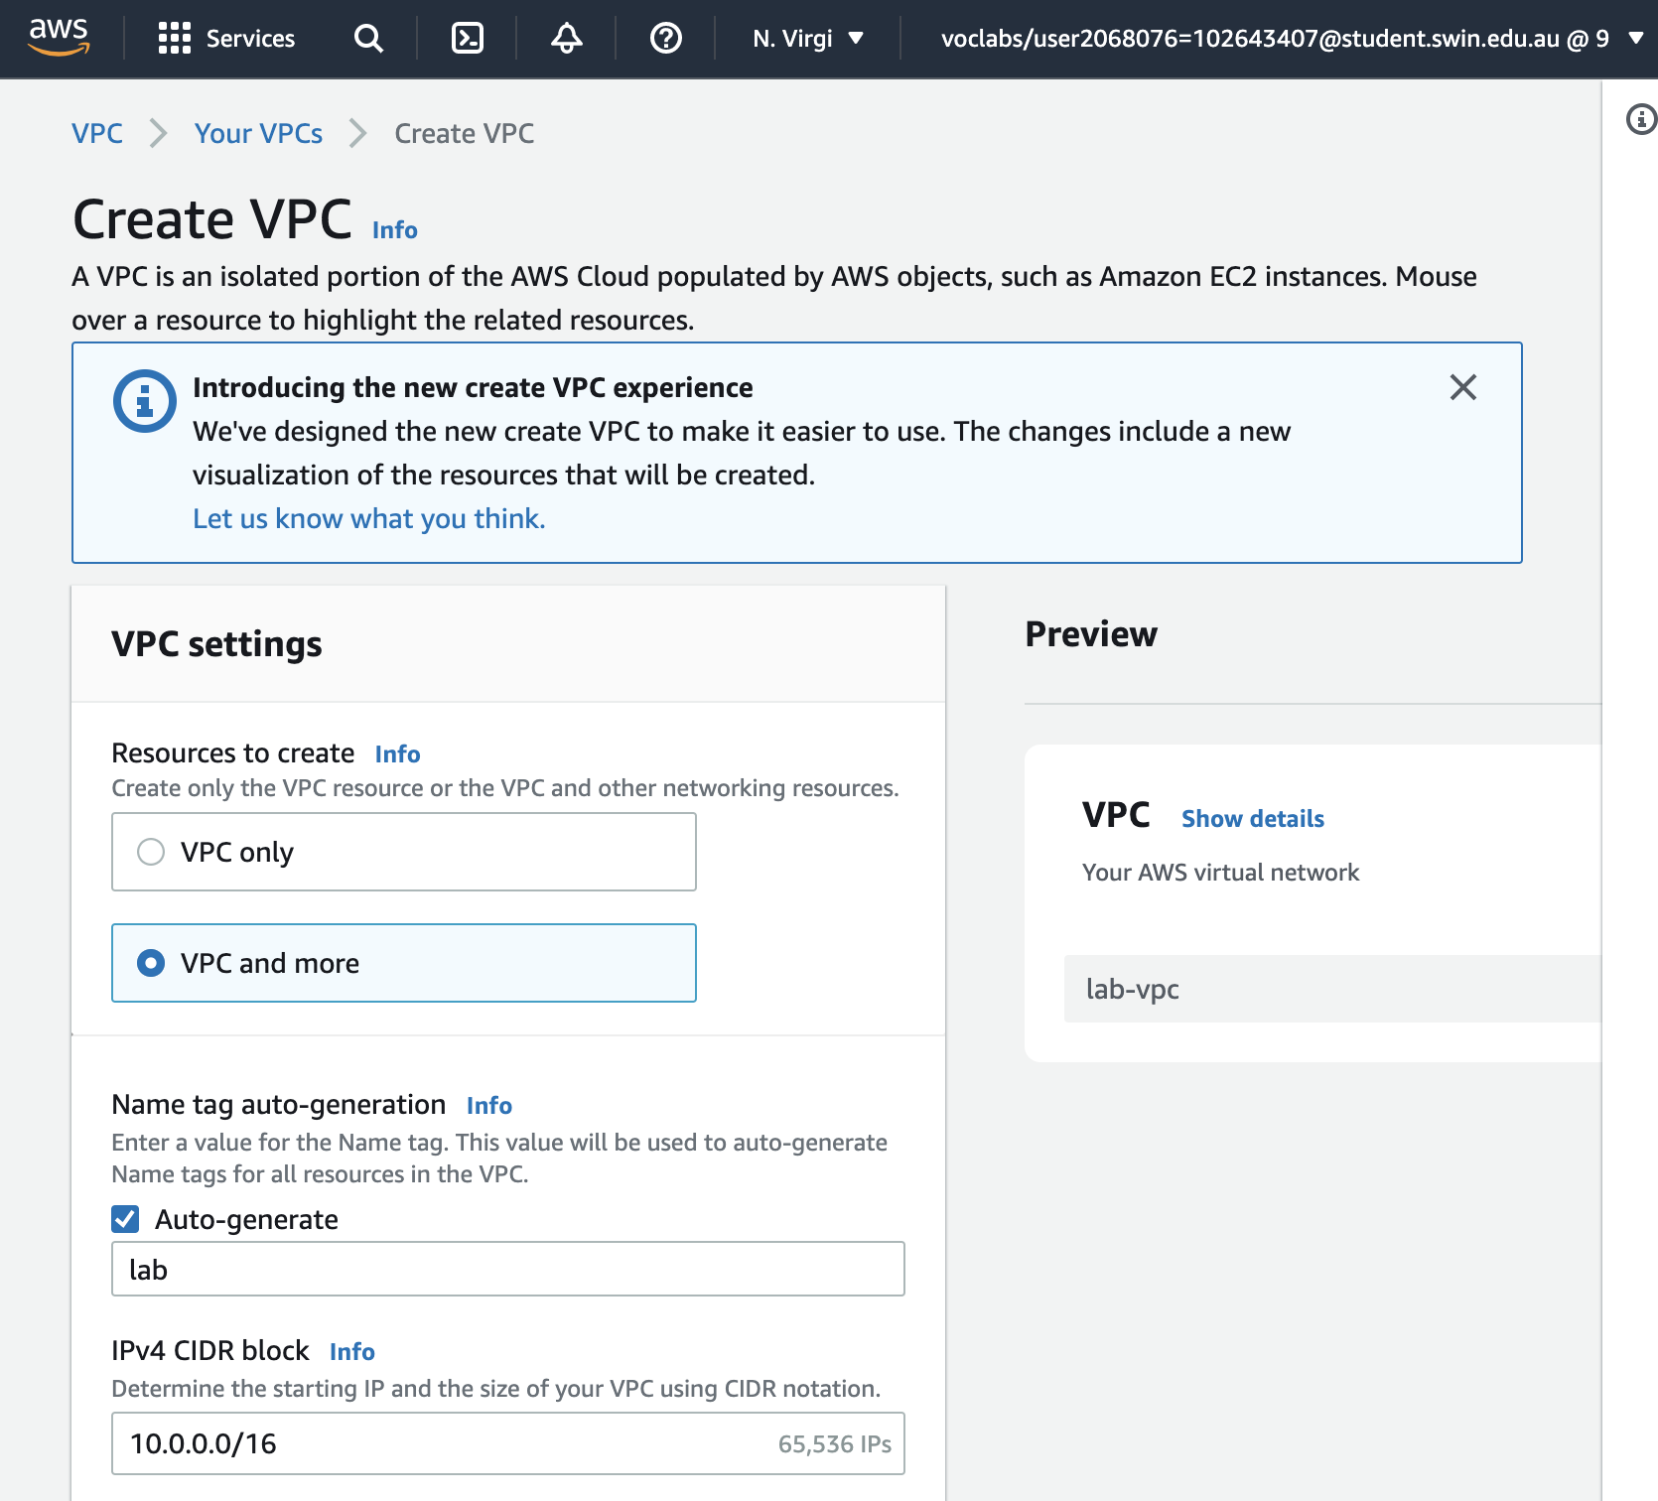

Configuring VPC as instructed

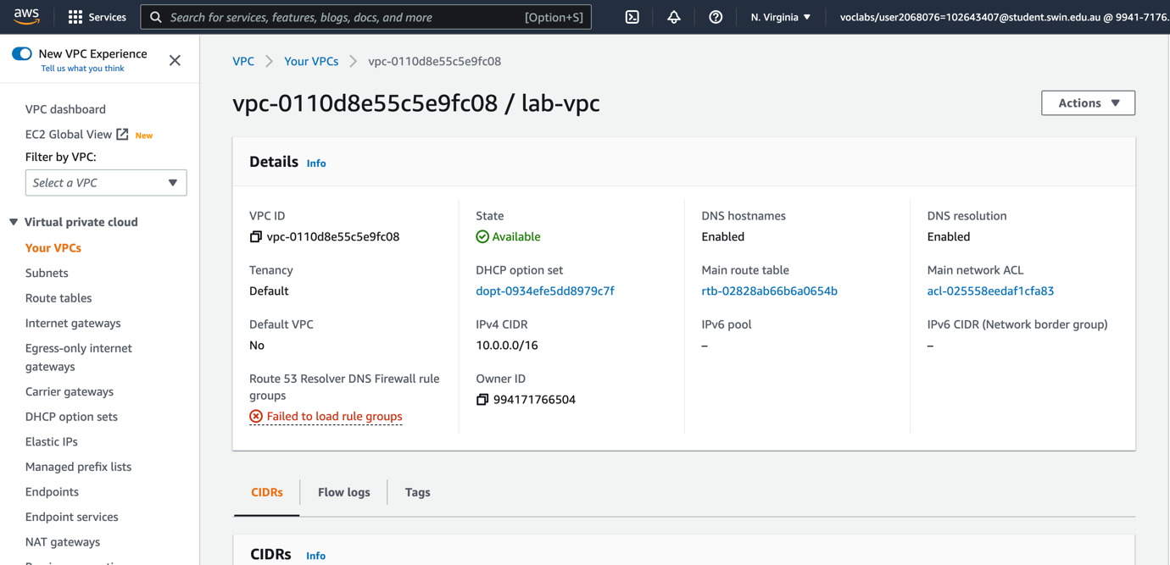

Successfully created new vpc

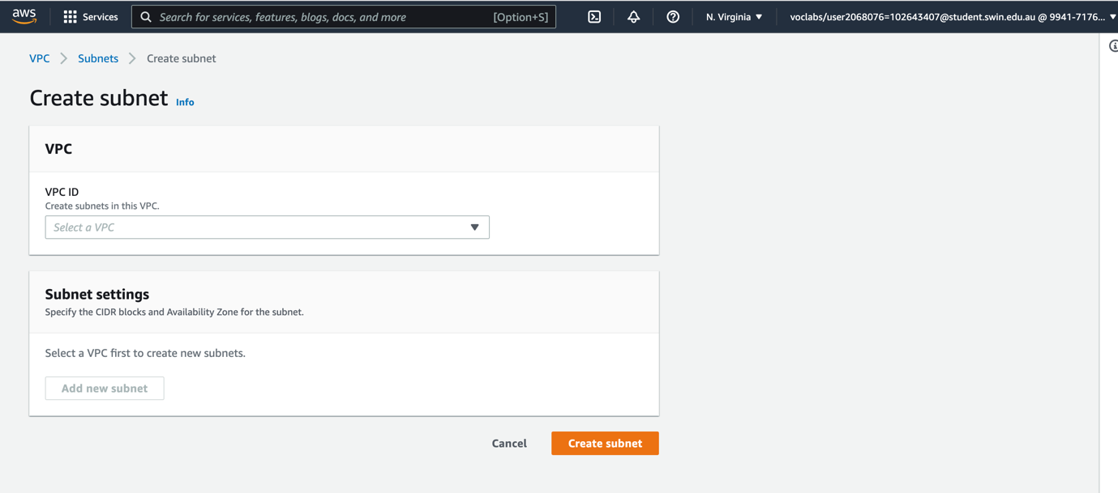

Creating subnet

Configuring subnet then create it

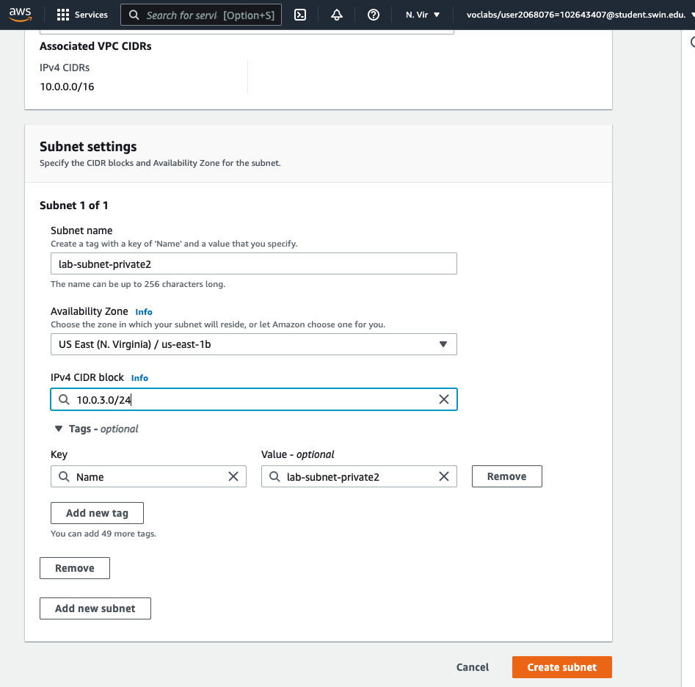

Configuring and creating second private subnet

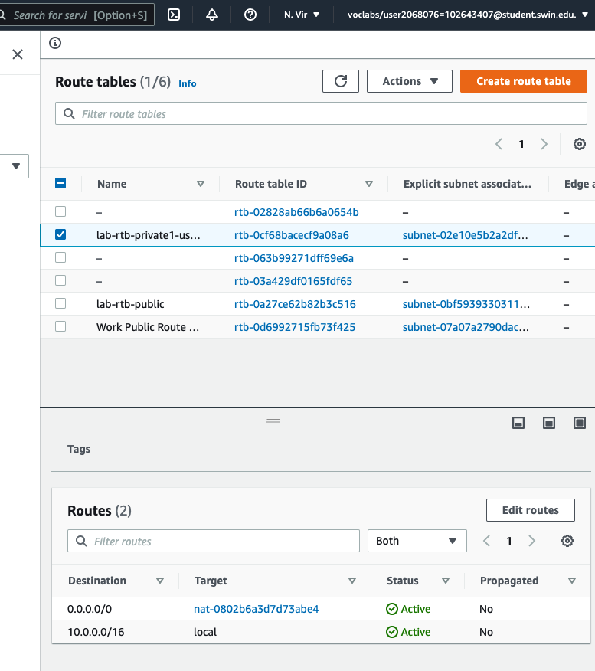

Configuring route for private subnet

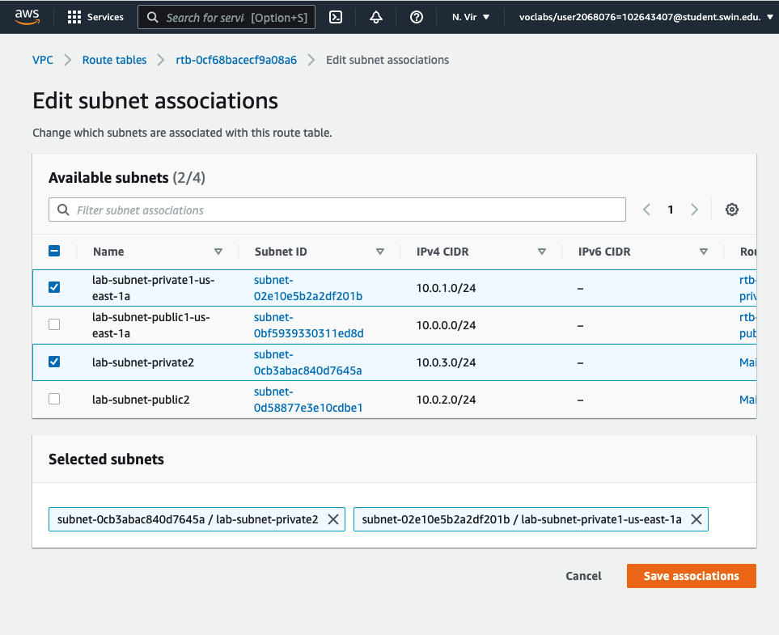

Associate route table with private subnet 2

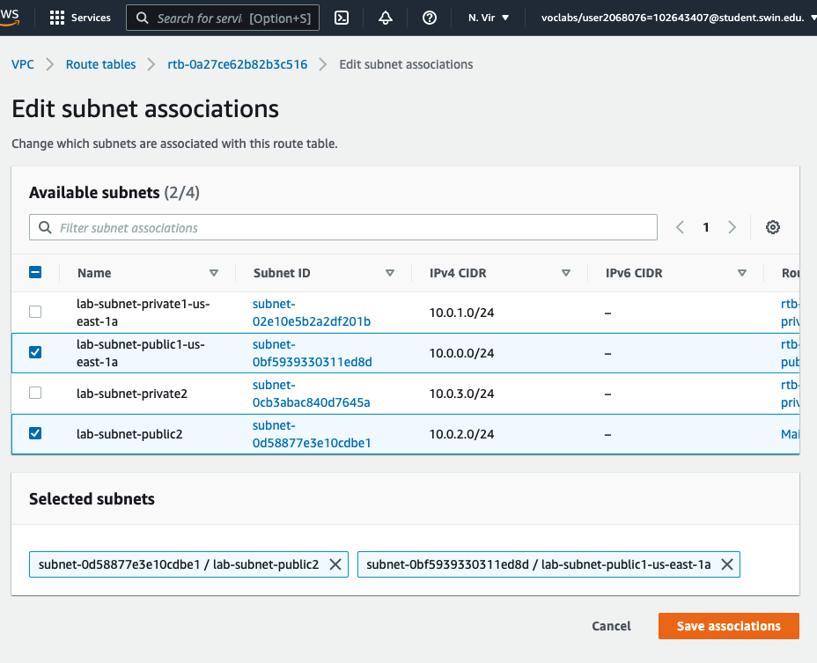

Associate route table with public subnet 2

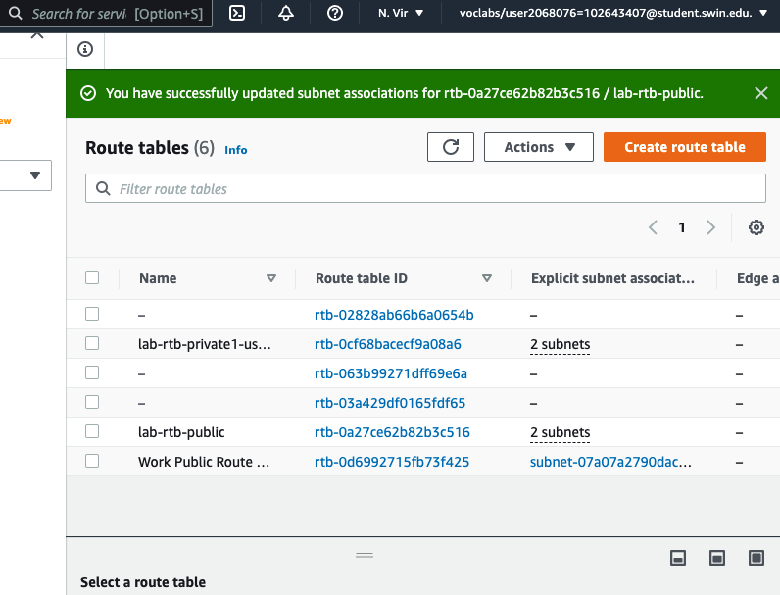

Successfully updated all subnet associations.

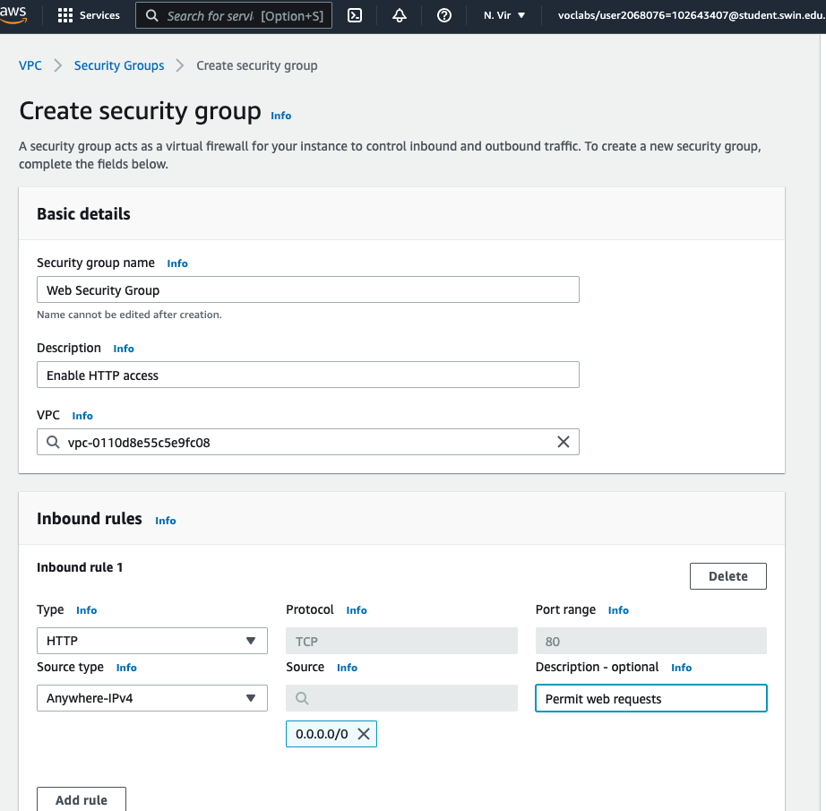

Configuring VPC security group

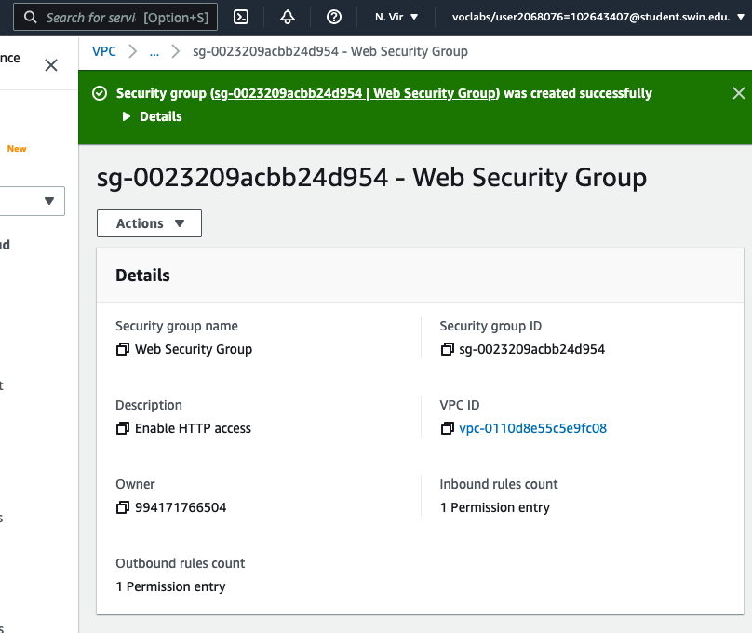

Successfully created security group

Configure an instance and launch it as instructed.

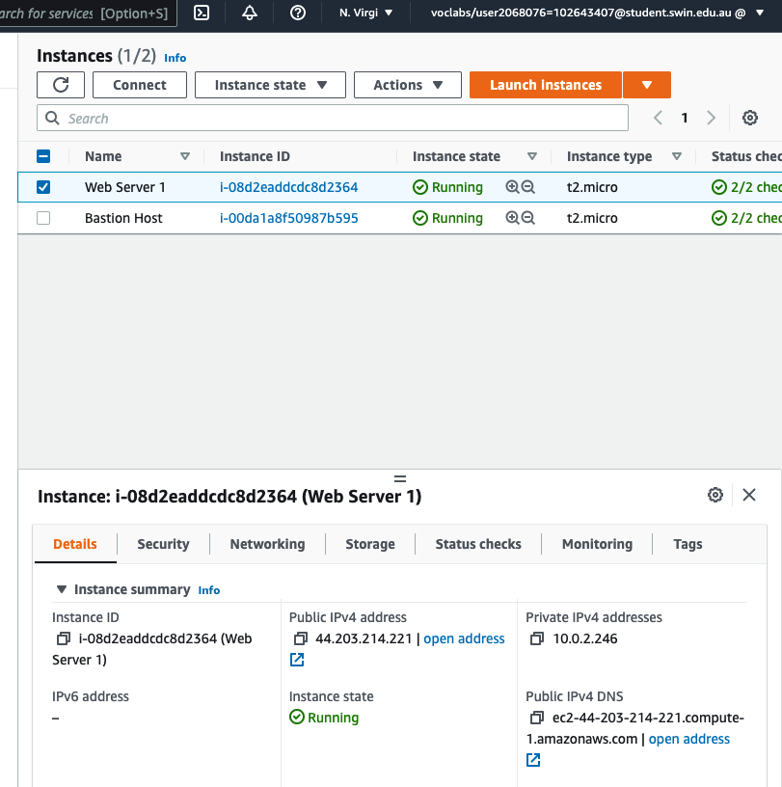

Last step, lab completed.